***You can access each of the poems below by clicking the title. See p. 2 for assistance with color-coded words.
Poem Title and Link | What thematic statement about war is offered in the poem? | What evidence is there of the speaker’s disillusionment? | What vivid imagery does the poet include? | How does the speaker have an out-of-body experience(s)?
“Anthem for Doomed Youth”
by Wilfred Owen

“Do Not Go Gentle Into That Good Night”
by Dylan Thomas

“The Soldier”
by Rupert Brooke

“Two Fusiliers”
by Robert Graves
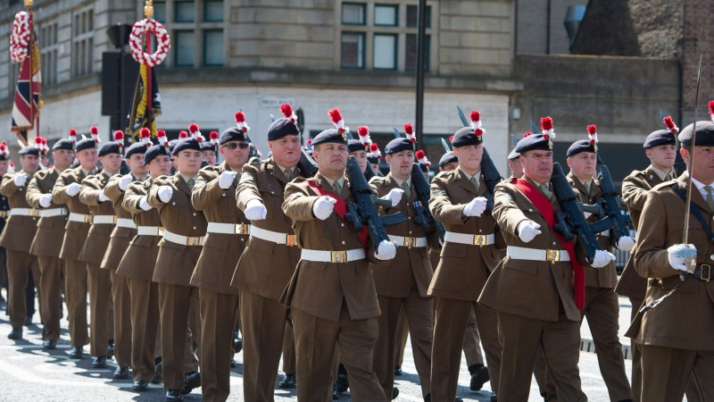

Thematic Statement – Remember that a theme/thematic statement should be a statement of opinion and reveal some aspect of how the world (or in this case, war) is.

Disillusionment -- a feeling of disappointment resulting from the discovery that something is not as good as one believed it to be. In literature, disillusionment is often marked by pessimism about how the world works and a fundamental distrust of human nature and goodness overall.

Out-of-Body Experiences – When analyzing the poem for out-of-body experiences, look for places where the speaker seems to be both experiencing a moment from a first-person point of view while also experiencing it from a third-person, omniscient point of (like an outsider).

