~~Victorian Era Introduction~~ ***For tasks/questions without a chart, answer on the back***

Snapshot of the Period (p.942-943)
Main Idea: The Victorian period witnessed dramatic ___________ ____________, rapid ____________, growth of ___________, political reforms, and the development of Britain into a _______________ _________________.
Main Idea: This era also witnessed the spread of _____________ and advances in _____________ and ____________ that threatened long-held _________________.
Tasks/Questions
1. Look at p. 943. If you were designing a “Crystal Palace” for today, 1) what materials would you use?, 2) what would the structure look like?, & 3) what exhibits would it contain?
Historical Background (p.944-945)
Main Idea: Queen Victoria’s reign was marked by __________ and ____________; she set out to restore the ________________ of the _______________.
Main Idea: _______________ became a very important concept in her time.
Tasks/Questions
1. Fill in the chart below to analyze the highs and lows of the empire:
Topic | Tragedy or Triumph? | Synopsis/Overview | Response
Irish Potato Famine
Great Exposition
Publishing
Reforms in Parliament
What is the Relationship Between Literature and Place? (p.946-947)
Tasks/Questions
1. Shade/color the map below to show all of the locations controlled by the British empire in 1897.
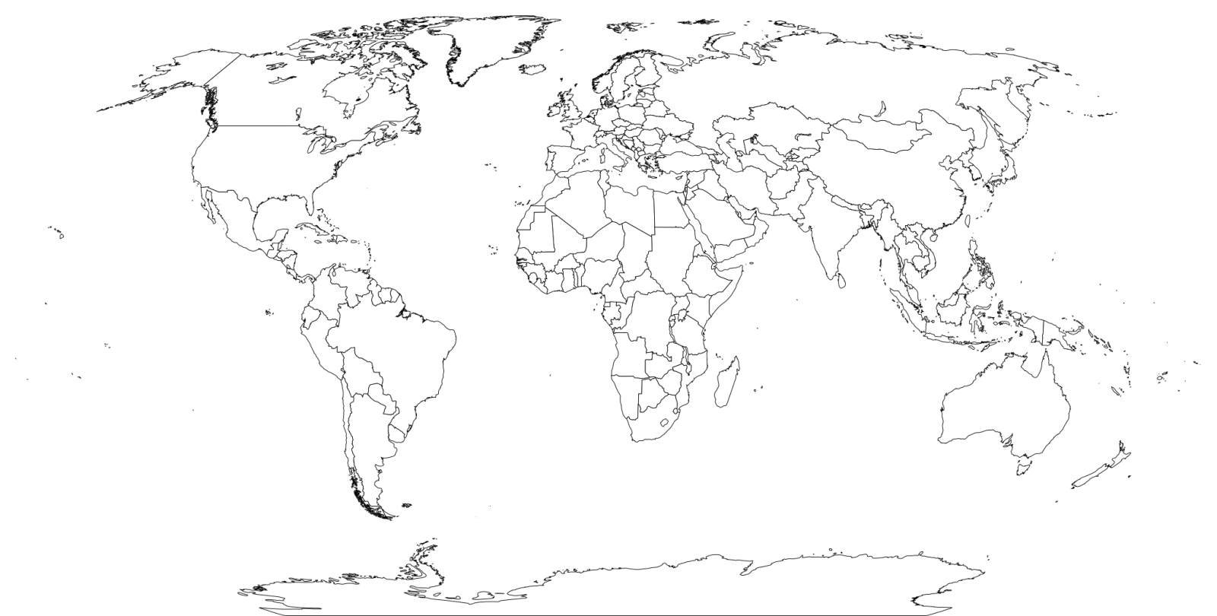
2. How was this far-reaching influence reflected back in the writings of British authors and poets?
How Does Literature Shape or Reflect Society? (p.948-950)
Tasks/Questions
1. Explain the following parts of Dickens’s quotation: 1) “it was the age of wisdom, it was the age of foolishness” 2) “we were all going direct to Heaven, we were all going direct the other way”
2. Read the box on p. 949 then list 4-5 euphemisms that we use in modern speech.
What is the Relationship of the Writer to Tradition? (p. 951-952)
Main Idea: As people talked of __________ and ____________, there was a brooding, ___________ tone to much of Victorian writing.
Main Idea: Published in _________ form, ____________ generated great excitement.
Tasks/Questions
1. Outline the style and subject matter of: dramatic monologues, novels, notes of melancholy

