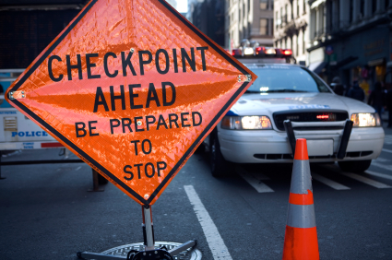 Sir Gawain Checkpoints Activity (While You Read)
Directions: After completing each section of the text as listed below,
pause to confirm your understanding of/analyze major events. (p.20)

Pages 171-173 (15 min)
- Provide the context in which the Green Knight enters?
- List 3 words that suggest the Knight’s opinion of himself?
- What “game” is the green knight proposing? What prediction can you make about the end result?
Pages 174-177 (25 min)
- Analyze how Arthur’s response shows potential character flaws?
- Sir Gawain is what relation to Arthur? How does/doesn’t he fit in with the other knights?
- Why does the green knight require that Sir Gawain seek him out at a later time?
- What occurs when Sir Gawain swings his axe?
- What explanation does Arthur give for the events that have happened?

Comic Strip Construction (After You Read) (10 min) 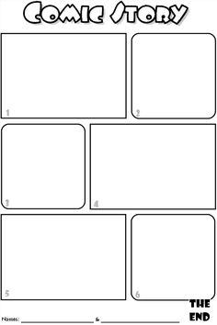
Directions: Once you have completed the checkpoint activity
listed above, create a comic strip to visualize the story thus far. (p. 20)

