Directions: Use the links before each question to help you answer it. Be sure that you answer all parts of each question for full credit.
A Revolution in Thought
http://www.allaboutscience.org/what-is-social-darwinism-faq.htm
1. What is social darwinism? How is it related to the work of Charles Darwin?
http://www.here-be-dreams.com/psychology/freud.html
2. Explain Freud's free association technique of dream interpretation?

The Great War
http://theconversation.com/the-soldiers-across-europe-who-were-excited-about-world-war-i-29807
http://politicalscience.osu.edu/faculty/jmueller/bjps11991.pdf
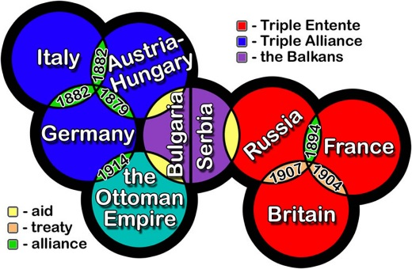
http://ww1centenary.oucs.ox.ac.uk/memoryofwar/continuations-or-new-beginnings-changing-attitudes-to-the-first-world-war/
3. How did western society feel about warfare in general before the Great War? How and why did this attitude change in the post-war period?
http://www.mrdowling.com/706-alliances.html
4. What is ironic about the alliance systems put into place in Europe?
http://www.teachertube.com/video/wwi-causes-720?utm_source=google&utm_medium=video&utm_campaign=preroll&utm_term=search&utm_content=video-ads
5. Watch the video above and list the causes suggested for WWI.

A Revolution in Literature
http://classiclit.about.com/od/literaryterms/g/aa_stream.htm
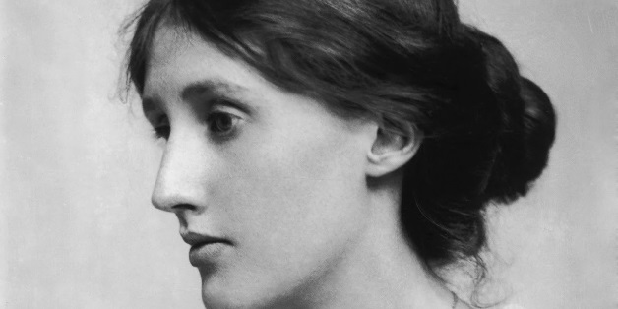
6. How does the "stream of consciousness" style of Virginia Woolf's writing differ from chronological storytelling?

http://study.com/academy/lesson/introduction-to-modernism.html
7. Name characteristics of modernism in literature as described by the video.
http://www.brighthub.com/education/k-12/articles/29453.aspx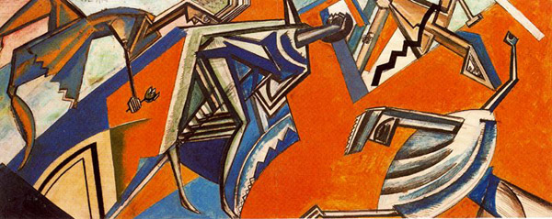
http://www.teachertube.com/video/modernism-in-literature-84360
8. Who were the main proponents of British Modernism and what were their major works?

Sunset of an Empire
http://www.wwnorton.com/college/english/nael/20century/topic_1/welcome.htm
9. What event is generally seen as marking the high point of the "second" British Empire?
(NO LINK REQUIRED)
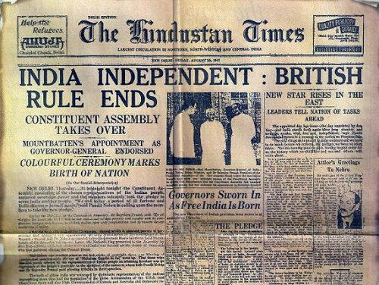
10. What aspects of both World Wars would have led colonists to believe in and fight for their independence?

