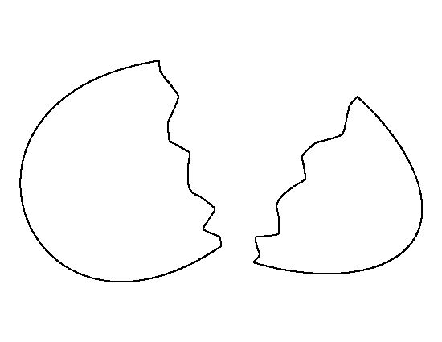
For each of the following aspects of Gulliver’s time in Lilliput, draw a connection to the human condition today (think: “how does this relate to current events?”). [p. 57]
1. The Big End vs. The Small End
2. Refusal to Compromise

3. Fear of the Unknown
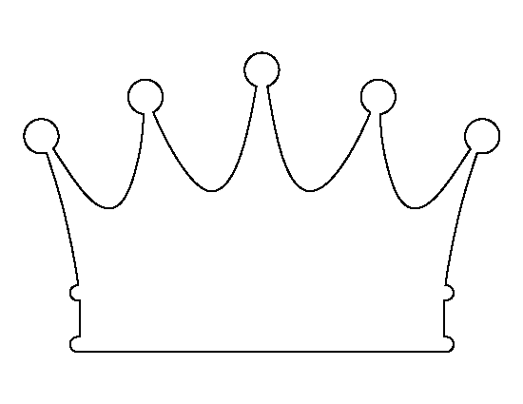
4. Desire for Power

