Directions: Fill in each section of the circle according to the headings. Use one half of each section for each text. Number your sections for each source: #1 – RR p. 444; #2 – RR p. 449; #3 – Green p. 266; #4 – Green p. 268. (Put 1 and 2 side by side, then 3 and 4 side by side)
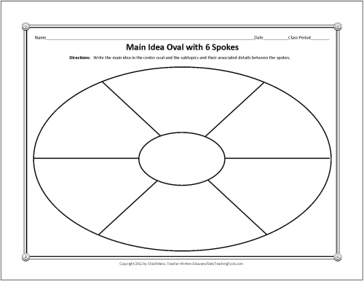
Is Support Sufficient?
Support
How Claim is Different from Counterclaim
Limitations of the Claim
Significance of Claim
Claim

