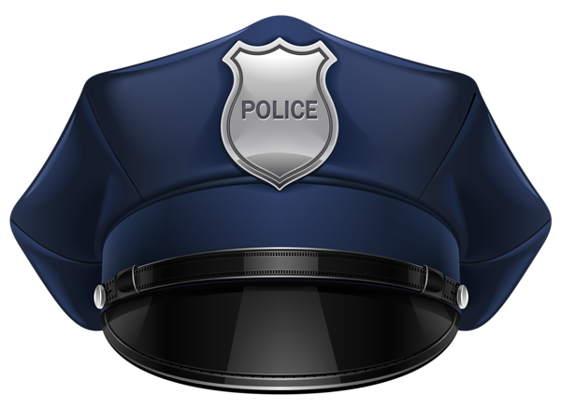
Act 5, Scene 1 Police Report
Background: In a more modern setting, the events of this scene would likely have followed with some sort of police investigation as to what happened.
Directions: Split the three tasks below amongst your group, one person per task, then compile your complete report for one overall product.

Task 1: The Basics of the Crime
Directions: Formatting as you wish, create a basic outline of the events of the crime using the elements suggested below:

a. Who ⎫ Who were the police officers? ⎫ Who are the victims, witnesses and suspects? ⎫ Who discovered the crime? ⎫ Who heard or saw anything important? ⎫ Who had access to the crime scene? b. What ⎫ What actually happened? ⎫ What crime was committed? ⎫ What evidence was obtained? ⎫ What happened to the evidence?
c. Where ⎫ Where did the crime happen? ⎫ Where were the victim, witnesses and suspects? ⎫ Where was the evidence found and stored?
d. When ⎫ When did the crime occur and when was it discovered? ⎫ When did officers arrive?
e. Why ⎫ Why was the crime committed? ⎫ Why did the suspect commit the crime?
f. How ⎫ How was the crime committed? ⎫ How was the entry made and how did the suspect leave?

Task 2: Identification of the Crime/Gathering Statements

1) Identify the crime committed (use the common name) then use an electronic device to research a specific statutory code for that crime, as well as the usual sentence for committing it.

2) Imagine you have gathered a statement from a victim or witness of the crime. What might they have said?

Task 3: Evidence Narrative

Evidence Narratives include everything the officer saw and did at the scene of the crime. Police report narratives are always written in chronological order so that there is never a need to back up to explain anything.

Directions: Create an evidence narrative as though you had visited the scene of the crime.

At a minimum, include descriptions of the following: • Arrival at scene, primary officer’s statement
• Security procedures taken • The incident scene • Marking, photography, collection of evidence
• Cataloging of Evidence (list of photos, prints, blood, physical evidence)

